Software Requirements Specification

for

English Dictionary

Version 1.0 approved

Prepared by

Nguyen Chau Thao Quan

Nguyen Hung Phuc

December 9, 2018

Table of Contents

1. Introduction 1

1.1 Purpose 1

1.2 Document Conventions 1

1.3 Definitions, Acronyms and Abbreviations 1

1.4 References 1

2. High Level Requirements 1

2.1 Product Perspective 1

Use Case Description 1

2.2.1 Diagram 1

2.2.2 User Description 3

2.2.3 Use Case Description 3

2.2.4 Use Case & User Permission Mapping 4

2.3 Operating Enviroment 4

2.4 Assumption and Dependencies 4

3. FUNCTIONAL REQUIREMENT 4

3.1 Module 01 4

3.1.1 UC01: Sign Up 4

3.1.2 UC02: Sign In 5

3.1.3 UC03: List of users 6

3.1.4 UC04: Account Personal Information 7

3.1.5 UC05: Search field 8

3.1.6 UC06: Language field 8

3.1.7 UC07: View History 9

4. Mockup Screen 9

4.1 SC01: Welcome Screen 9

5. Nonfunctional Requirements 9

5.1 Accessbility 9

5.2 Volume 10

5.3 Precision 10

5.4 Performance 10

5.5 Compatibility 10

5.6 Maintainability 10

5.7 Safety 10

5.8 Portability 10

6. System Constraint 10

6.1 Database 10

6.2 Device 11

6.3 Programming Language 11

Revision History

|  |  |  |  |
| --- | --- | --- | --- |
| **Name** | **Date** | **Reason For Changes** | **Version** |
|  |  |  |  |
|  |  |  |  |

# Introduction

## Purpose

This Software Requirement Specification version 1.0 provide a complete description of all the function and specification of the English dictionary project. This document is intended to sign the contract with the customer and to be used by the members of the software engineering team that will implement and verify the correct function of the system.

## Document Conventions

None

## Definitions, Acronyms and Abbreviations

|  |  |  |
| --- | --- | --- |
| **#** | **Abbreviation** | **Explaination** |
| 1 | SRS | Software Requirement Specification |
| 2 | UC | Use Case |
| 3 | SC | Screen |
| 4 | MS | Messages |

## References

|  |  |  |  |  |
| --- | --- | --- | --- | --- |
| **Title** | **Author** | **Version** | **Date** | **Source Location** |
|  |  |  |  |  |

# High Level Requirements

## Product Perspective

This product use the translate technique which is similar to google translate system. When user search any word, it will show the English description, pronounciation and the meaning of that word, including the audio that will play all the English description, pronounciation.

## Use Case Description

### Diagram

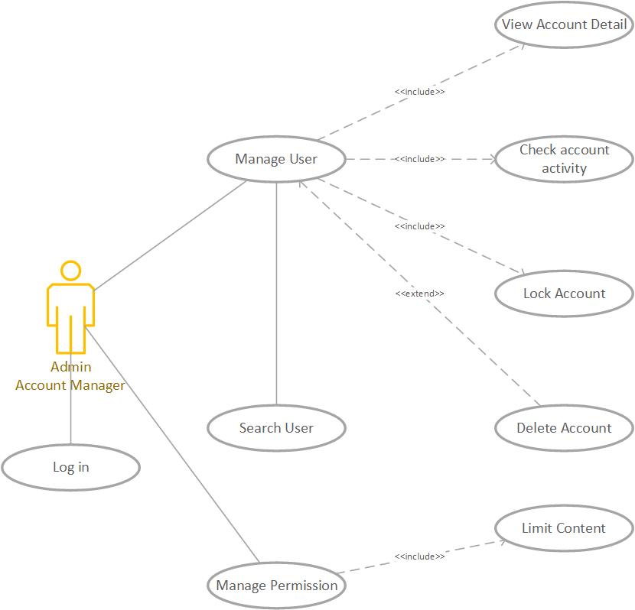

Diagram 1: Admin and Account Manager Permission

**Notes: Admin and account manager can access all function**

### User Description

Diagram 2: Dictionary System

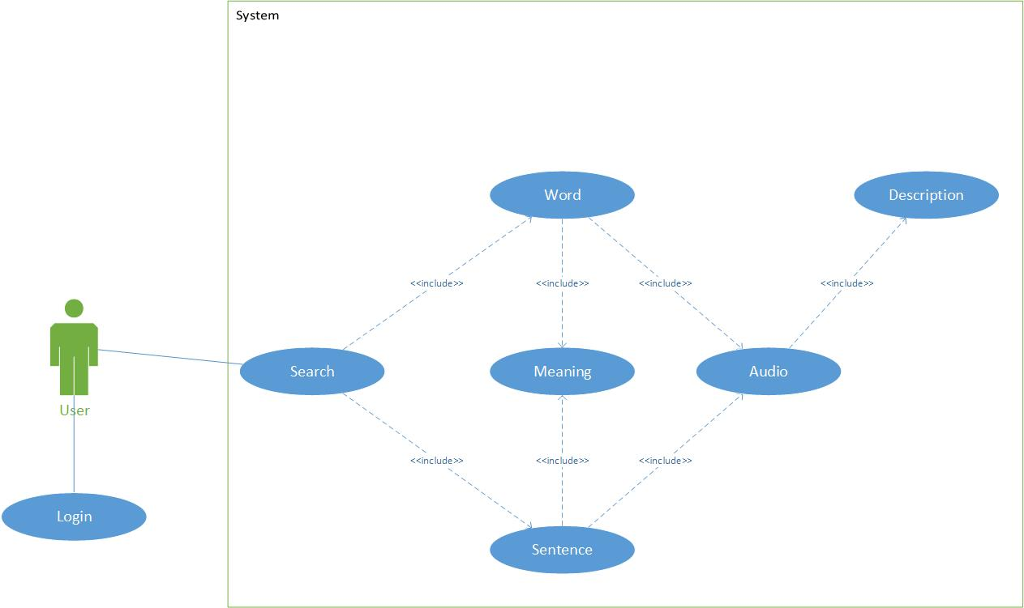

|  |  |  |
| --- | --- | --- |
| **#** | **User Permission** | **Definition** |
| 1 | Admin |  |
| 2 | Account Manager |  |
| 3 | Guest |  |

### Use Case Description

|  |  |  |  |
| --- | --- | --- | --- |
| **#** | **ID** | **Name** | **Brief Description** |
| 1 | UC01 | Sign Up | User can create account to use the translate function |
| 2 | UC02 | Sign In | User can Login when they create account success |
| 3 | UC03 | List of user | Account Manager can see and manage the user account |
| 4 | UC04 | Account personal information | User can see and change their personal information |
| 5 | UC05 | Search field | User can enter the words or sentences to find the meaning |
| 6 | UC06 | Description section | User can see the word they enter and the meaning of that one |
| 7 | UC07 | Audio | User can hear the sound of that word |
| 8 | UC08 | View History | User can see the words they enter all the times |

### Use Case & User Permission Mapping

|  |  |  |  |  |
| --- | --- | --- | --- | --- |
| **Use Case** | **Use Case Name** | **Admin** | **Account Manager** | **Guest** |
| UC01 | Sign Up | X | X | X |
| UC02 | Sign In | X | X | X |
| UC03 | List of user | X | X |  |
| UC04 | Account personal information | X | X | X |
| UC05 | Search field | X | X | X |
| UC06 | Language field | X | X | X |
| UC07 | View History | X | X | X |

## Operating Enviroment



## Assumption and Dependencies

# FUNCTIONAL REQUIREMENT

## Module 01

### UC01: Sign Up

|  |  |  |  |  |  |
| --- | --- | --- | --- | --- | --- |
| **ID** | **Name** | **Account** | **Trigger** | **Pre-condition** | **Post condition** |
| UC01 | Sign Up | Admin/Account Manager/Guest | User press the Sign Up button |  | Move to Sign Up form |

Activities

|  |  |  |  |
| --- | --- | --- | --- |
| **User** | | **System** | |
| Main flow: Sign Up Success | | | |
| 1 | User press sign up button. (SC01) |  | |
|  |  | 2 | Move to the Sign Up forms. (SC02) |
| 3 | User enter their name, email, password and tick the box I agree. |  |  |
|  |  | 4 | Validate the field and the check the password. |

System Messages

|  |  |
| --- | --- |
| MS01 | Please enter your name. |
| MS02 | Please enter your email. |
| MS03 | Please enter your password. |
| MS04 | The password is not matched. |
| MS05 | Cannot create account when the check box I agree is missing. |

### UC02: Sign In

|  |  |  |  |  |  |
| --- | --- | --- | --- | --- | --- |
| **ID** | **Name** | **Account** | **Trigger** | **Pre-condition** | **Post condition** |
| UC02 | Sign In | Admin/Account Manager/Guest | User press the Sign In button |  | Move to homepage |

**Activities**

|  |  |  |  |
| --- | --- | --- | --- |
| **User** | | **System** | |
| Main flow: Sign In Success | | | |
| 1 | User press sign in button (SC02) |  | |
|  |  | 2 | Move to the Sign Up forms (SC03) |
| 3 | User enter their name, email, password and tick the box I agree |  |  |
|  |  | 4 | Validate the field and the check the password. |

System Messages

|  |  |
| --- | --- |
| MS06 | Please enter your name This notification will appear when user let the name field is empty |
| MS07 | Please enter your email This notification will appear when user let the email field is empty |
| MS08 | Please enter your password  This notification will appear when user let the password field is empty |
| MS09 | The password is not matched  This notification will appear when 2 password from input isn’t same |
| MS10 | Cannot create account when the check box I agree is missing This notification will appear when user let the check box isn’t ticked |

### UC03: List of users

|  |  |  |  |  |  |
| --- | --- | --- | --- | --- | --- |
| **ID** | **Name** | **Account** | **Trigger** | **Pre-condition** | **Post condition** |
| UC03 | List of users | Admin/Account Manager | Admin/Account Manager press the icon user button |  | Move to List of users |

Activities

|  |  |  |  |
| --- | --- | --- | --- |
| **User** | | **System** | |
| Main flow: Move to List of User successful | | | |
| 1 | User press the icon (SC04) |  | |
|  |  | 2 | Show the list of users (SC05) |
| 3 | Admin/Account manager can lock or set the permission of account |  |  |

System Messages

|  |  |
| --- | --- |
| MS11 | Set up complete Admin/Account manager set the user permission successful |
| MS12 | Access denied Account isn’t admin or account manager can’t access when Admin/Account manager lock that one |

### UC04: Account Personal Information

|  |  |  |  |  |  |
| --- | --- | --- | --- | --- | --- |
| **ID** | **Name** | **Account** | **Trigger** | **Pre-condition** | **Post condition** |
| UC04 | Account Personal Information | Admin/Account Manager/Guest | User press the Account detail |  | Move to personal information page |

Activities

|  |  |  |  |
| --- | --- | --- | --- |
| **User** | | **System** | |
| Main flow: Sign Up Success | | | |
| 1 | User press personal information detail(SC06) |  | |
|  |  | 2 | Move to the personal information page (SC07) |
| 3 | User enter their new name, email, password. |  |  |
|  |  | 4 | Validate the field and the check the password by request their password again. |
| 5 | User enter the password to confirm |  |  |
|  |  | 6 | Notice when user type successful or not |

System Messages

|  |  |
| --- | --- |
| MS13 | Password is not match this message will appear when 2 password from user are not match |

### UC05: Search field

|  |  |  |  |  |  |
| --- | --- | --- | --- | --- | --- |
| **ID** | **Name** | **Account** | **Trigger** | **Pre-condition** | **Post condition** |
| UC05 | Search field | Admin/Account Manager/Guest | Admin/Account Manager/Guest enter any word or sentences and press search button. |  | Find the specific word to translate. |

Activities

|  |  |  |  |
| --- | --- | --- | --- |
| **User** | | **System** | |
| Main flow: Search successful | | | |
| 1 | User enter the words or sentences. |  | |
|  |  | 2 | Check this is words or not Check this is sentences or not. |
| 3 | Translate from English to Vietnamese or vice versa. |  |  |

System Messages

|  |  |
| --- | --- |
| MS11 | This is not the words The word or sentence that user entered contain the special characters. |

### UC06: Language field

|  |  |  |  |  |  |
| --- | --- | --- | --- | --- | --- |
| **ID** | **Name** | **Account** | **Trigger** | **Pre-condition** | **Post condition** |
| UC06 | Language field | Admin/Account Manager/Guest |  |  | Translate a word or a sentence from English to Vietnamese or vice versa |

Activities

|  |  |  |  |
| --- | --- | --- | --- |
| **User** | | **System** | |
| Main flow: Search successful | | | |
| 1 | Enter a word which don’t have any special characters. |  |  |
|  |  | 2 | Translate this word from English to Vietnamese when user enter the word to search correct. |

### UC07: View History

|  |  |  |  |  |  |
| --- | --- | --- | --- | --- | --- |
| **ID** | **Name** | **Account** | **Trigger** | **Pre-condition** | **Post condition** |
| UC07 | View History | Admin/Account Manager/Guest | Admin/Account Manager/Guest click the view history button |  | See the word they looked up |

Activities

|  |  |  |  |
| --- | --- | --- | --- |
| **User** | | **System** | |
| Main flow: View History page | | | |
|  |  | 1 | Show the user the word history list |

# Mockup Screen

## SC01: Welcome Screen

# Nonfunctional Requirements

## Accessbility

User enter 1 character and show the list of the words that have that character.

User can use their voice to fill the word automatically.

## Volume

Number of user can access at least 100 peoples.

## Precision

The word must be translated when the words or sentenced have uppercases in any location.

The word received from user’s voice must be filled corect.

Audio must be spoken correct depends on the description.

## Performance

The word that user look up show the result under 5s.

The web application is responsive.

## Compatibility

The application must run on web browser.

The application run on windows 7 or higher.

## Maintainability

All functions can be possibly colliped.

Add more functions when needed.

## Safety

The account management system will check the account activity when the bad behavior appear (pollitic, system security,…).

## Portability

The application run on device with any hardware:

* PC or laptop with minimum CPU core 2 duo, 2GB of rams or modern one.

# System Constraint

## Database

The application translate the word through firebase or MySQL

## Device

The application run only on destop or laptop.

## Programming Language

Can write with the scripting language(HTML/CSS,JavaScript,PHP,...) or high level language (C/C++, python,java,...).